**Q.1 Write a shell script to produce a multiplication table.**

Solution: -  
  
Step1: - touch multiplication_table.sh  
Step 2: - nano multiplication_table.sh  
Step 3: -

#! /bin/bash

echo "Enter the number for which you want to generate the multiplication table: "

read number

echo "Enter the range of the table (up to which you want multiple):"

read range

echo "Multiplication table for $number up to $range:"

for (( i=1; i<=$range; i++ )); do

result=$((number * i))

echo "$number x $i = $result"

done

Step 4: - chmod +x multiplication_table.sh

Step 5: - ./multiplication_table.sh

**nano multiplication_table.sh**

**Output of the Program**

**Q.2 Write a shell script program to implement a small calculator.**

Solution:-

Step 1: - touch calculator.sh

Step 2: - nano calculator.sh

Step 3:-

#! /bin/bash

echo "Select operation:"

echo "1. Addition"

echo "2. Subtraction"

echo "3. Multiplication"

echo "4. Division"

read choice

echo "Enter first number:"

read num1

echo "Enter second number:"

read num2

case $choice in

1)

result=$((num1 + num2))

operator="+"

;;

2)

result=$((num1 - num2))

operator="-"

;;

3)

result=$((num1 * num2))

operator="*"

;;

4)

if [ $num2 -eq 0 ]; then

echo "Error: Division by zero"

exit 1

fi

result=$(echo "scale=2; $num1 / $num2" | bc)

operator="/"

;;

*)

echo "Invalid choice"

exit 1

;;

esac

echo "$num1 $operator $num2 = $result"

Step 4: - chmod +x calculator.sh

Step 5: - ./calculator.sh

**nano calculator.sh**

**Output of the Program**

**Q 3. Write a shell script to display prime numbers up to the given limit.**

Solution:-

Step 1: - touch prime_number.sh

Step 2: - nano prime_number.sh

Step 3: -

#! /bin/bash

echo "Enter the limit:"

read limit

echo "Prime numbers up to $limit:"

for ((num = 2; num <= limit; num++)); do

is_prime=true

for ((i = 2; i * i <= num; i++)); do

if ((num % i == 0)); then

is_prime=false

break

fi

done

if $is_prime; then

echo $num

fi

done

Step 4: - chmod +x prime_number.sh

Step 5: - ./prime_number.sh

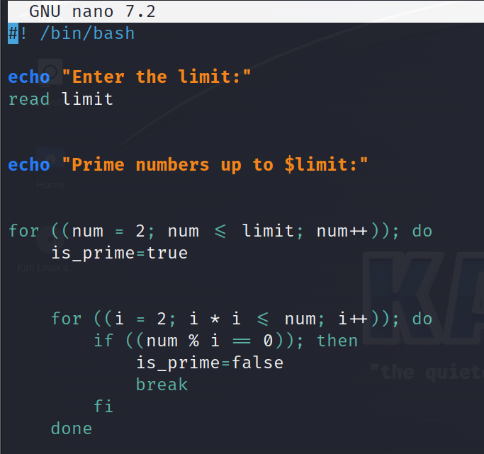

**nano prime_number.sh**

**Output of the Program**

**Submitted By: -**  
**Shrey Garg**  
**K22QY**

**12218692**

**Submitted To: -**

**Mr. Ashish Kumar Singh**